**Unit 1.5 – Pyret Activity 1**

**Working with Functions in Pyret**

1. Draw a sketch of the Fahrenheit-Celsius graph below.

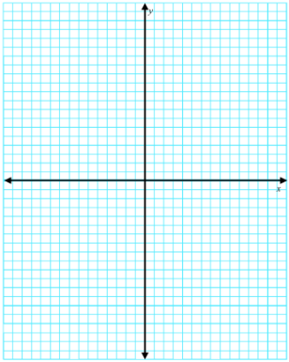

1. What was the equation of the function that we had determined for the conversion between Fahrenheit and Celsius?

1. Show the work to convert 10° C to Fahrenheit.

1. Show the work to convert 50° C to Fahrenheit.

# Design Recipe Worksheet

Purpose of this function is to convert a temperature in degrees Celsius to a temperature in degrees Fahrenheit.

## Contract+Purpose Statement

Every contract has three parts:

# ______________ : __________________________ → ______________________

name Domain Range

# _______________________________________________________________________ What does the function do?

## Give Examples

Write examples of your function in action

examples:

________________(________________________)

the function application…

is _________________________________________________

...which evaluates to

________________(________________________)

the function application…

is _________________________________________________

...which evaluates to

end

## Function

Find the changes in the examples, and name the variables.

Write the code, copying everything that isn't circled, and using names where you find variables!

fun ____________:

_____________________________________________

end

**ON YOUR OWN**

1. Invert the table from the lab for Celsius and Fahrenheit.

|  |  |
| --- | --- |
| **Fahrenheit** | **Celsius** |
|  |  |
|  |  |
|  |  |
|  |  |
|  |  |
|  |  |
|  |  |

1. Graph the data, this time with Celsius on the vertical axis, and Fahrenheit on the horizontal.

1. Determine the Best Fit Line Equation of this graph, aka the function to convert from Fahrenheit to Celsius.

1. Show the work to convert 10° F to Celsius.

1. Show the work to convert 50° F to Celsius.

# Design Recipe Worksheet

Purpose of this function is to convert a temperature in degrees Fahrenheit to a temperature in degrees Celsius.

## Contract+Purpose Statement

Every contract has three parts:

# ______________ : __________________________ → ______________________

name Domain Range

# _______________________________________________________________________ What does the function do?

## Give Examples

Write examples of your function in action

examples:

________________(________________________)

the function application…

is _________________________________________________

...which evaluates to

________________(________________________)

the function application…

is _________________________________________________

...which evaluates to

end

## Function

Find the changes in the examples, and name the variables.

Write the code, copying everything that isn't circled, and using names where you find variables!

fun ____________:

_____________________________________________

end